INTEGRATING HUMAN RIGHTS IN UN PEACEBUILDING RESPONSE TO FARMER-HERDER CRISIS IN MIDDLE BELT, NIGERIA
SEPTEMBER, 2020 REPORT
- EXECUTIVE SUMMARY

1.1The clashes between farmers and herders in Nigeria particularly in the middle belt have led to grave human rights and humanitarian crisis. The clashes have resulted in fatalities, injuries, displacements, destruction of livelihoods as well as properties and this has heightened religious and ethnic hostilities within the region.
1.2With a record of over 1800 fatalities within the first half of 2018 alone, the fatality rate relating to farmer-herder clashes is higher than that attributed to the Boko Haram insurgency.

  - Responding to the huge humanitarian crisis and displacements caused by the clashes, several stakeholders commenced humanitarian actions to ameliorate the sufferings of displaced persons and to generally facilitate peace building within the region.

  - Following apparent gaps in the humanitarian response, the National Human Rights Commission in collaboration with the Office of the High Commissioner for Human Rights (OHCHR) conceived a project titled “Integrating Human Rights in UN Peace-building Response to the Farmer-Herder Crisis in the Middle Belt” to run for a period of 18 months. Some of the objectives of the project include:
- To understand security trends and allow for a deeper understanding of the famers-herders crisis, including root causes, and facilitating the design of targeted responses to address the crisis and attendant human rights violations;

- To improve the capacity of key stakeholders, security and government actors on the application or integration of human rights norms in response to the crisis;

- To enhance preventive capacities by promoting dialogue and proactive engagement between farmers and herders with the aim of building mutually beneficial economic relationships between farmers and herders;

- To improve the effectiveness of the security response through strengthened human rights monitoring and accountability; and providing an impartial and evidence-based narrative to defuse the politicized debate and help mobilize a broader response to the crisis;

- To provide opportunities for lessons learned and developing best practices, including for demonstrated conflict prevention programming that delivers peace dividends to affected populations in different contexts.

  - The Project which is expected to last for 18 months and is currently focused on 15 Local Government Areas (LGAs) of Benue State (Guma, Logo, Ukum, Katsina Ala, Gwer East, Gwer West, Makurdi, Buruku, Tarka, Otukpo, Agatu, Kwande, Ogbadibo, Oju and Gboko) with potentials of scaling the project to other States.

METHODOLOGY

  - A Field Officer/Monitor resident in each of the above LGAs was appointed and tasked with the responsibility of sending weekly reports on identified thematic areas and protection issues (in his or her area of operation) to the Project Team made up of Staff of NHRC for analysis and onward transmission to OHCHR.
Figure: 1

1.7This report therefore details incidents of violence, findings, observations and human rights outreach programs carried out by the monitors during the Month of September, 2020.

2.0 INCIDENTS OF VIOLENCE
2.1 The report showed that there were 83 cases of Physical violence leading to prevalence of human rights Violations in Guma, Makurdi and Ukum alone other local governments recorded a lower number in the Month of September, 2020. There were 28 arrest and Detention, 1 Extrajudicial killings from the incidents of violence, 33 harassment issues, 0 trafficking, 5 destruction of properties, 64 destruction of farmlands which were recorded in attacks and communal clashes in the communities with significant increase in violence from Guma and Makurdi. These issues cut across these 10 local Governments as shown below.
2.2 Figure 1.
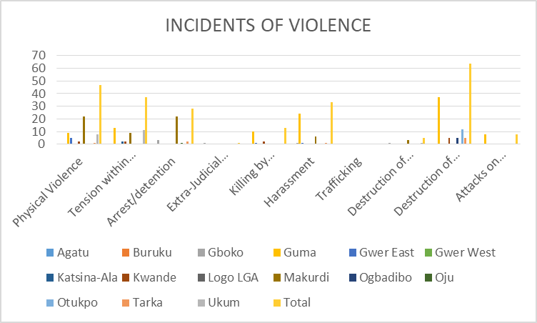

2.2. The deaths recorded in September, 2020 were majorly from communal clashes. This shows a significant decrease in farmer herder related killings.

3.0 CHILD PROTECTION ISSUES
3.1 The September, 2020 report showed that there were 4 cases of Child abuse, 19 cases of Child forced Labor, 51 cases of Child begging/hawking, 23 cases of unaccompanied/ separated children, no case of child recruitment by armed groups and 5 cases of Child headed households as shown in figure 2.
3.2. Child labour was prevalent in Guma, Katsina-Ala and Makurdi LGA while child abuse cases were prevalent in Karsina-Ala LGA. There was also prevalence of unaccompanied children/orphans in Guma LGA.
Figure 2.
CHILD PROTECTION ISSUES
 | Unaccompanied/Separate Children | Child Forced Labour | Child Begging and hawking | Child abuse | Child recruitment by armed groups | Child Headed Household
Agatu | 0 | 0 | 0 | 0 | 0 | 0
Buruku | 0 | 0 | 0 | 0 | 0 | 0
Gboko | 3 | 0 | 6 | 0 | 0 | 5
Guma | 15 | 11 | 4 | 0 | 0 | 0
Gwer East | 0 | 0 | 0 | 1 | 0 | 0
Gwer West | 0 | 0 | 0 | 0 | 0 | 0
Katsina-Ala | 0 | 5 | 0 | 2 | 0 | 0
Kwande | 0 | 0 | 8 | 0 | 0 | 0
Logo LGA | 0 | 0 | 0 | 0 | 0 | 0
Makurdi | 0 | 3 | 30 | 1 | 0 | 0
Ogbadibo | 0 | 0 | 0 | 0 | 0 | 0
Oju | 0 | 0 | 1 | 0 | 0 | 0
Otukpo | 0 | 0 | 0 | 0 | 0 | 0
Tarka | 4 | 0 | 2 | 0 | 0 | 0
Ukum | 1 | 0 | 0 | 0 | 0 | 0
Total | 23 | 19 | 51 | 4 | 0 | 5

Figure 3
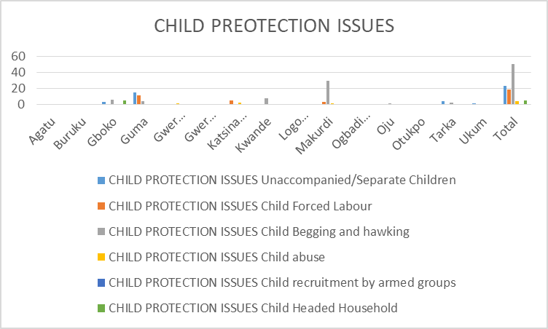

4.0 WOMEN PROTECTION ISSUES
4.1 A total of 118 women protection issues were identified during the reporting period of September, 2020. 6 cases of early/forced marriages were recorded in Guma and Gwer East LGA Out of this number, Makurdi had 4 cases of rape including sexual and gender based violence. There were a total of 20 cases of Harassment, while 11 security threats were recorded against women/girls.
4.2 There were also 13, 13 and 15 incidents of domestic violence/neglect in Logo ,Makurdi, and Oju LGAs respectively. There were 16 cases of Physical Violence in Gboko and Guma LGA. This is represented in figure 4 below.

Figure 4: WOMEN PROTEFCTION ISSUES
 | Rape/Sexual Abuse/Sexual exploitation | Sex for food | Physical violence | Forced/early marriage | Domestic Violence/ Neglect | Harrasment | Security threats against Women/girls
Agatu | 0 | 0 | 0 | 0 | 0 | 0 | 0
Buruku | 0 | 0 | 0 | 0 | 0 | 0 | 0
Gboko | 0 | 0 | 0 | 0 | 0 | 0 | 5
Guma | 0 | 0 | 14 | 4 | 0 | 16 | 11
Gwer East | 1 | 0 | 0 | 2 | 0 | 0 | 0
Gwer West | 1 | 0 | 0 | 0 | 0 | 0 | 0
Katsina-Ala | 0 | 0 | 1 | 0 | 3 | 1 | 0
Kwande | 1 | 0 | 0 | 0 | 0 | 0 | 0
Logo LGA | 0 | 0 | 0 | 0 | 0 | 0 | 0
Makurdi | 4 | 0 | 2 | 0 | 20 | 1 | 0
Ogbadibo | 0 | 0 | 0 | 0 | 0 | 0 | 0
Oju | 0 | 0 | 0 | 0 | 1 | 0 | 0
Otukpo | 0 | 0 | 0 | 0 | 23 | 0 | 0
Tarka | 0 | 0 | 3 | 0 | 4 | 2 | 0
Ukum | 0 | 0 | 3 | 0 | 4 | 0 | 0
Total | 7 | 0 | 23 | 6 | 55 | 20 | 16

FIGURE 5.

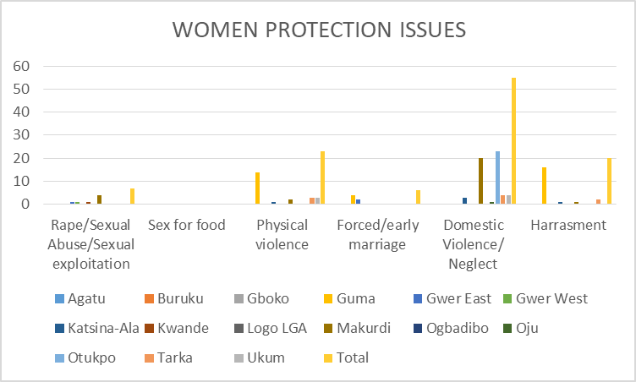
5.0 PERSONS WITH SPECIFIC NEEDS (PSN)
5.1The report showed that there were 19 and 16 cases of pregnant and lactating mothers in Guma and Gwer East LGAs respectively. Guma and Gwer East LGAs also recorded the highest number of elderly persons.
5.2 It was observed that majority of the serious medical conditions were recorded in Ogbadigbo LGAs . It is pertinent to note that the women headed households was the highest demography of persons with specific needs within this reporting period of September, 2020. This is represented below in figures 6 and 7.
Figure 6. PERSONS WITH SPECIFIC NEEDS

 | Female headed households | Pregnant and lactating mothers | Persons with disability | Elderly | Serious medical conditions.
Agatu | 0 | 0 | 0 | 0 | 0
Buruku | 0 | 0 | 0 | 0 | 0
Gboko | 15 | 0 | 2 | 3 | 0
Guma | 31 | 19 | 0 | 30 | 0
Gwer East | 14 | 16 | 5 | 20 | 0
Gwer West | 0 | 0 | 0 | 0 | 0
Katsina-Ala | 7 | 8 | 0 | 8 | 0
Kwande | 2 | 8 | 1 | 0 | 0
Logo LGA | 0 | 0 | 0 | 0 | 0
Makurdi | 14 | 13 | 7 | 13 | 2
Ogbadibo | 125 | 0 | 12 | 0 | 21
Oju | 0 | 0 | 0 | 0 | 0
Otukpo | 35 | 14 | 13 | 9 | 6
Tarka | 28 | 14 | 5 | 30 | 6
Ukum | 0 | 0 | 0 | 0 | 0
Total | 271 | 92 | 45 | 113 | 35

Figure 7.
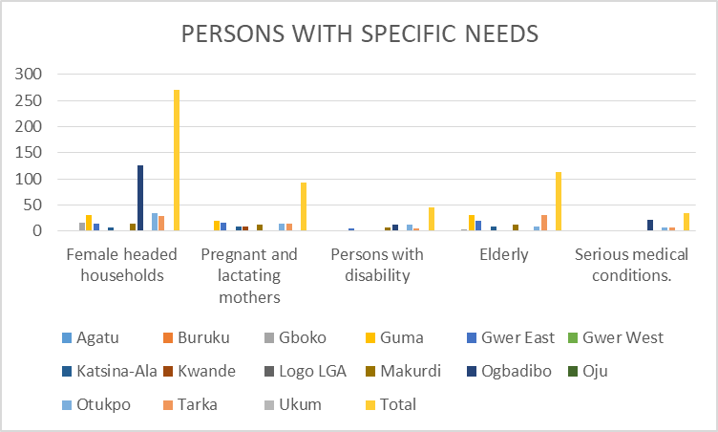

6.0 ACCESS TO JUSTICE
6.1The report showed that a total of 18 persons were arrested and detained by security officials, most of the arrests were in Tarka LGA. Some of them were persons who engaged in crimes as a means of feeding themselves and members of their families.
6.2 It is worthy to note that the number of people that had access to justice were not many because there were less casualties under this category in the reporting period of September 2020, Some cases were resolved by elders and village heads within the reporting month as shown below.
Figure 8.

ACCESS TO JUSTICE
 | Court case | Documentation | Arrest & Detention | HousingLand & property
Agatu | 0 | 0 | 0 | 0
Buruku | 0 | 0 | 0 | 0
Gboko | 2 | 0 | 4 | 0
Guma | 0 | 0 | 0 | 0
Gwer East | 0 | 0 | 4 | 0
Gwer West | 0 | 0 | 2 | 0
Katsina-Ala | 0 | 0 | 0 | 0
Kwande | 0 | 0 | 0 | 0
Logo LGA | 0 | 0 | 0 | 0
Makurdi | 0 | 0 | 0 | 3
Ogbadibo | 0 | 0 | 0 | 0
Oju | 0 | 0 | 1 | 0
Otukpo | 0 | 0 | 0 | 0
Tarka | 1 | 0 | 2 | 0
Ukum | 0 | 0 | 5 | 0
Total | 3 | 0 | 18 | 3

Figure 9 :
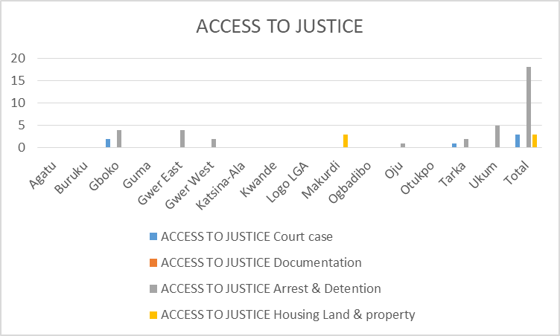

7.0 COMMUNITY OUTREACH PROGRAMMES
7.1 The report shows that the monitors conducted a total of 6942 community outreach programmes, awareness sessions, interfaith dialogue, etc for the promotion and protection of human rights in Buruku, Guma, Gboko, Makurdi, Katsina- Ala, Gwer East, Gwer–West and Logo, Ogbadibo, Otukpo and tarka LGAs.
7.2 The Report also showed that 1811 boys, 1725 girls, 1619 men and 1988 women were reached during the outreach programs.
8.0 SERVICES (REPORTS ON RIGHTS OF IDPs ON ISSUES/SERVICES LISTED)
RIGHTS OF IDPs
8.1 The Reports shows that IDPs who were displaced as a result of the farmer-herder crisis and currently residing in camps and host communities in Guma, Logo, Makurdi and Ukum LGAs are in dire need of food, health and educational facilities as well as non-food items such as clothes, toiletries, beddings, detergents, hand sanitizers, Masks, sanitary items cooking utensilsand any other preventive measure against the Corona Virus.

8.2 In some IDP camps in Buruku, Logo, Katsina-Ala and Ukum LGAs, there are insufficient Health and Psycho-Social Support, drugs, teachers and educational materials. In Guma LGA, there are no school activities because of the COVID 19 lockdown.

8.3 The Report also shows that there is need for infrastructural development in some of the IDP camps especially in Buruku, and Guma LGAs, because the IDPs in the camps were not able to isolate themselves from one another, as a result of the infrastructural depreciation in the camps, which could hypothetically give rise to concerns of the catching and spread of the COVID 19 Virus, and the IDP Camp health personnel did not put in place the right preventive measure for the IDPs

8.4 Government agencies such as SEMA, National Emergency Management Agency (NEMA) and other humanitarian actors providing interventions to IDPs, in camps, (although these efforts are still not sufficient) should spread their reach to IDPs in host communities. This has increased the crime rate within the area as some IDPs now take to crime to survive.

9.0 RECOMMENDATIONS
Given the protection issues identified for the Month of September, 2020, the following actions are recommended:
- There should be more deployment of health personnel to the camps and host communities, because of the COVID 19 Pandemic, there should be more sensitization on the pandemic and provisions of protective materials, kits and gears.

- There should be a disarmament programme for herdsmen and famers as a strategy to building lasting peace between farmers and herders in the middle belt region.

- There should be more peace talks between the communities, spear headed by the community leaders and other stakeholders, because communal clashes are leading to a large number of deaths in the state

- There should be deployment of more security agents in Logo, Kwande, Guma, Makurdi, Gwer East, Gwer West and Ukum LGAs in order to check the activities of armed robbers, cultists as well as other criminalities arising from the farmer/herders crisis.

- There should be more support in provision of food, drugs, shelter and other essentials items by NEMA, SEMA, CSOs and humanitarian agencies to assist IDPs in official camps as well as those in host communities.

6. There should be more community outreaches and peace talks between communities, human rights sensitizations and town hall meetings, because it seems that the ones that were previously held have been yielding results, as seen from the impressive reduction in number of death toll resulting from the farmer-herders clashes.
CONCLUSION
The Commission thanks OHCHR for its continued support, the monitors and project team of the Commission for working tirelessly to produce this report. The Commission hopes that this report and others to come will galvanize requisite humanitarian interventions, facilitate broad based accountability measures and peace-building efforts to the famers-herders crisis in Nigeria.

